DON BOSCO COLLEGE
ANGADIKADAVU, KANNUR – 670 706

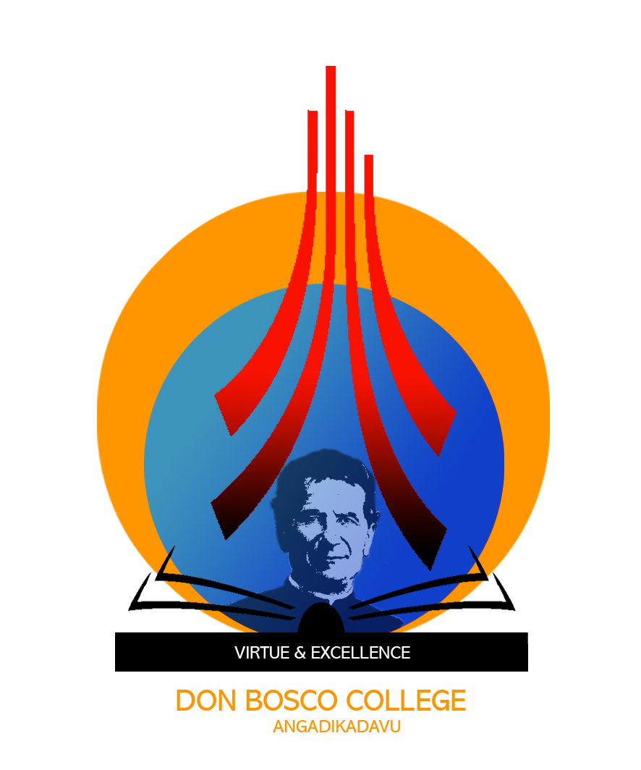

CERTIFICATE

This is to certify that the project entitled HIRE AND BUILD submitted in partial fulfillment of the requirement for the award of M.C.A Degree is a result of bonafide work carried out by SAYOOJ.P during the year 2019.

Internal Guide External Guide
Mr.Diljith K Benny (Name, Designation & Address)
Assistant Professor
DonBosco College Angadikadavu

Head of the Institution
Don Bosco College
Angadikadavu, Kannur

Examiner 1
Examiner 2

